Name ________________________ Date _________________________

Show what you know!
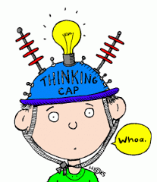
You had some stickers on your binder. Your best friend gave you 7 more. Now there are 10 stickers on your binder. How many stickers were there already?

There were 4 people at your birthday party. Some more people came after supper. Now there are 9 people at your party. How many people came after supper?

You had 9 books on your shelf and you brought home 5 more from the book swap. How many books are your shelf altogether?

Name ________________________ Date _________________________

Show what you know!
You had some stickers on your binder. Your best friend gave you 21 more. Now there are 40 stickers on your binder. How many stickers were there already?

There were 19 people at a dance party. Some more people came after supper. Now there are 37 people at the dance party. How many people came after supper?

You had 23 books on your shelf and you brought home 15 more from the book swap. How many books are your shelf altogether?

