Name ________________________ Date _________________________

Show what you know!
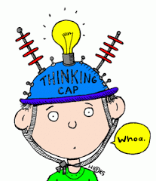
You saw some ducks in a field and 7 geese. You saw 12 birds in the field. How many ducks did you see?

There are 5 cars and some trucks on the road. There are 15 vehicles altogether. How many trucks are on the road?

You had 7 dog books and 8 cat books. How many books do you have altogether?

Name ________________________ Date _________________________

Show what you know!
You saw some ducks in a field and 17 geese. You saw 42 birds in the field. How many ducks did you see?

There are 25 cars and some trucks on the road. There are 45 vehicles altogether. How many trucks are on the road?

You had 27 dog books and 18 cat books. How many books do you have altogether?

