Name ________________________ Date _________________________

Show what you know!
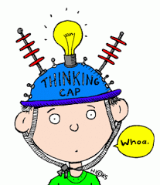
You had some stickers on your binder. 4 fell off. Now there are 7 stickers. How many were on your binder before any fell off?

There were 14 people at your birthday party. Some people had to leave early. Now there are 9 people at your party. How many people left early?

You had 15 valentines in your envelope. You gave 6 away. How many valentines do you have left?

Name ________________________ Date _________________________

Show what you know!
You had some stickers on your binder. 14 fell off. Now there are 27 stickers. How many were on your binder before any fell off?

There were 24 people at your birthday party. Some people had to leave early. Now there are 19 people at your party. How many people left early?

You had 35 valentines in your envelope. You gave 16 away. How many valentines do you have left?

